

**Job Name: Land at Go Green Waste Recycling Ltd, Eridge Road, TN6 2DZ**

**Date: 15th January 2023   
Prepared By: Alexia Tamblyn**

**Subject: Ecological Technical Note – Go Green Site Visit and Recommendations for Ecological Enhancements.**

The Ecology Partnership was commissioned by Go Green Waste to provide an ecological enhancement strategy to review the site in terms with East Sussex consideration for changes to planning permission WD/703/CM. Variation to three conditions has been sought, however, a review from East Sussex suggests a new application is sought.

The site is located to the north of the A26. The location of the site is shown in figure 1 below, and the wider landscape as shown in Figure 2.

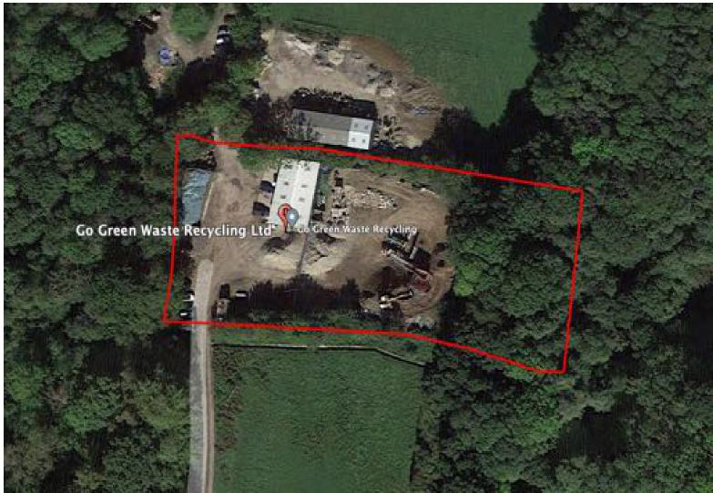

***Figure 1: Approximate location of the site as shown by the red line boundary***



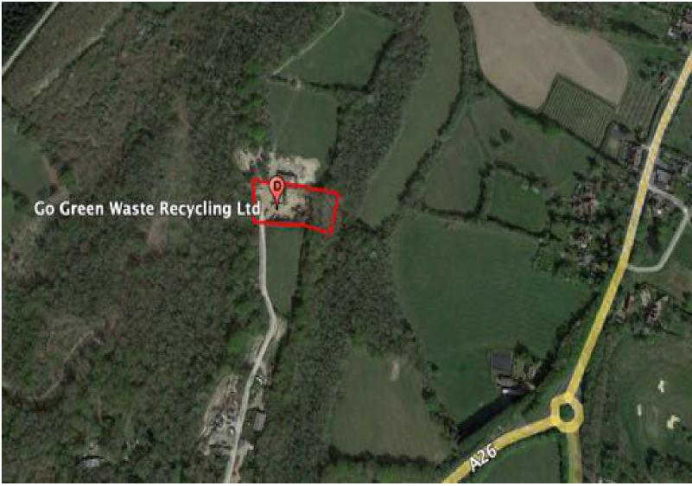

***Figure 2: Approximate location of the site as shown by the red line boundary in the wider landscape***

The site adjoins the Boars Head, Hodges and Cage Woods LWS. Cage Wood lies to the west of the site, which is an extensive area of ancient woodland. The closest area of woodland to the site is lowland deciduous woodland, and is not designated as ancient (see figure 3 below). To the east of the site lies Loxford Shaw which is linked to Newham Shaw and further to the north east Hodges Wood, which in turn extends north and west to Cage Woods. There is connectivity to other large blocks of ancient woodland throughout the local area.

Figure 3 and figure 4 shows clearly that the site directly abuts the ancient woodland to the west, Cage Wood, and no 15m buffer zone is provided (in line with Natural England’s standing advice). However, this edge and lack of buffer, is historic given the constraints of the site, it would appear that any meaningful buffer zone would compromise site activities and result in the change in access and compromise other business access to the north of this site. It must be noted that a 15m buffer is present between the ancient woodland on the eastern portion of the site.

Permission for the alteration / extension of the site is not requested, however, in relation to the site and the surrounding area, recommendations for the management of the site and ecological enhancements have been detailed below.

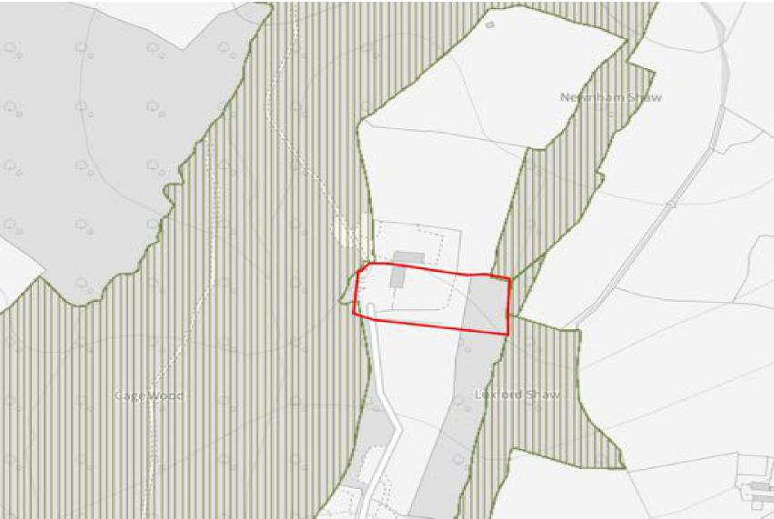

*Figure 3: The approximate red line boundary and the location of the ancient woodland in relation to the*

*red line boundary*

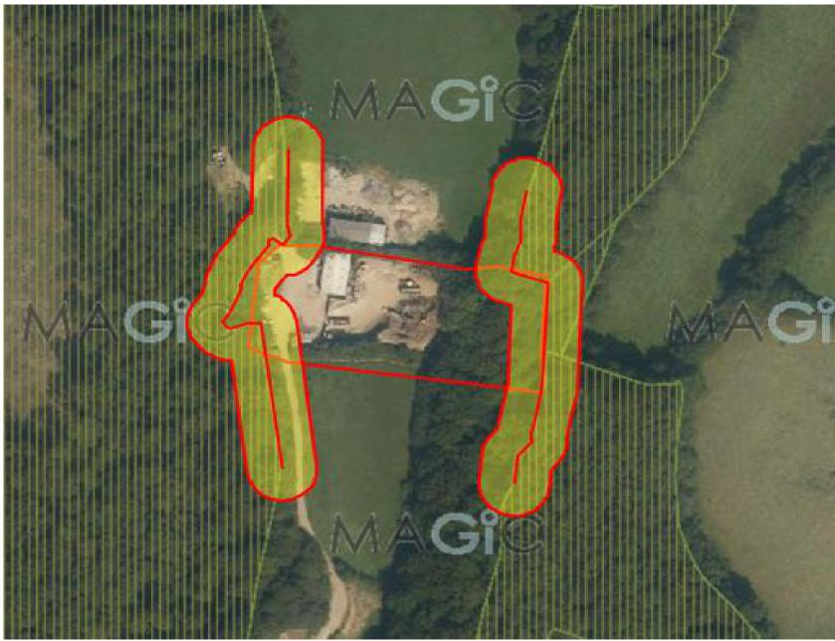

*Figure 4: Location of the 15m ancient woodland buffer (yellow) in relation to the site*

***Site Visit***

The site was visited on the 23rd November 2022 by Alexia Tamblyn from the Ecology Partnership. The survey was conducted to assess the current site layout and to provide recommendations for the ancient woodland / woodland habitats.

The site was almost 100% hardstanding / made up ground. The edge habitats, notably the woodland (Cage Wood) to the west, supported hazel and oak woodland, with some elements of old hazel coppice. Due to the time of year no significant ground flora was noted. To the east, the lowland deciduous woodland which connects to Loxwood Shaw and Newnham Shaw, was located down a slope towards a stream at the base of the slope and the woodland habitats were considered more in line with a ghyll woodland. An area of habitat on the east had been subject to disturbance where waste materials were stored on the top of the slope.

***Site Recommendations***

The two main recommendations for the site are for the provision of site delineation on both the east and western edges, to ensure no encroachments into either woodland habitats as a result of the operations of the site.

On the west, adjacent to the ancient woodland, storage bays are constructed, and as such no encroachment beyond these bays is considered likely. With tree overhang, construction is considered unsuitable as this could impact the integrity of the tree line. However, it is recommended, that on top of each of the bays, a small fence line is attached along the western edge, to prevent any excess stored materials being blown into the woodland. This would not involve any excavations, but would need fixed to the current concrete bays and provide a screen.

The second woodland edge, located on the east side of the, on top of the slope above the woodland, would need to be built to allow water run off from the site. This should be a fixed fence line should include gabion walls which support a Geotech filter fabric which stops silts and clays (small sediments) moving into the wall and beyond into the ghyll below. This would require a specialist consultant. However, once established, this will reduce / remove sediment movement into the habitats within the adjacent woodland and stream on the eastern side of the site.

In terms of ecological enhancements, the following is recommended to provide some benefits to a range of protected species within the adjacent habitats;

* The provision of dormouse boxes within adjacent woodland. Within the woodland under the Go Green ownership this is easily achieved and an ecologist should be instructed to establish these in suitable habitats. A total of 5 boxes would be established in this woodland. On the woodland outside the Go Green boundary, additional boxes could be established and should be done so under consultation with the land owner. A further 5 – 10 boxes could be established in the adjacent and off site woodland. These boxes provide new opportunities for dormice nesting and can uplift the carrying capacity of the site in terms of dormice populations. Boxes are unobstructive and do not require significant management or investment. However, it is recommended that these are monitored by a suitably qualified ecologist.
* Bat boxes should be established in the Go Green owned woodland. Mature trees are present in the woodland on thee astern aspect of the site. It is considered that a total of three bat boxes could be established within this woodland. It is recommended that a suitably qualified ecologist is employed to establish these within the woodland.
* The habitat to the south of the site, which is currently a field and managed lightly, appears to be rush pasture / localised rush habitat and neutral grassland. Due to issues with localised flooding and run off, alder, willow and birch could be planted along the southern boundary of the Go Green site, or within an area identified of low ecological value within the field, to reduce water flow into the site itself, without significantly impacting the field south and ensuring that the rush pasture is largely preserved. The creation of two / three lines of trees, once established, would help prevent significant water ingress into the site .

***Conclusions***

The site is heavily constrained by the woodland to the east and west of the site and the creation of a 15m buffer between the activities and ancient woodland is not possible. Recommendations to prevent incursion from water / sediment in to the adjoining woodlands has been made. It is recommended that a specialist is consulted with regards to the gabion wall construction on the eastern side of the site.

With regards to ecological enhancements, recommendations for the provision of bat and dormouse boxes has been made within the woodland habitats. This could provide some opportunities to enhance the carrying capacity of the woodland habitats for these species.

Additional planting of trees to the south could also help reduce run off and sedimentation. The provision of some tree planting should not reduce the overall value of the field to the south, but provide a mosaic of habitats within.

It is considered that these provisions will reduce impacts on adjacent woodland habitats and provide some site level enhancements and support a review of the planning process.

If you have any questions or queries, then please do not hesitate to get in touch.   
Many thanks



Alexia Tamblyn MA (Oxon) MSc CEcol CEnv MCIEEM FRGS   
Managing Director

Appendix 1: Site Photographs

|  |  |
| --- | --- |
|  |  |
| Photo 1: The yard area |
| Photo 2: The edge of the yard in relation to the woodland to the east. It is recommended that a gabion wall is constructed along this edge to prevent sediment run off. |

|  |  |
| --- | --- |
|  |  |
| Photo 3: The bays along the ancient woodland edge on the west of the site. It is recommended that screens / fence is attached to the concrete sides to reduce any impacts from dust / sediment. |
| Photo 4: Neutral grassland with rushes. Potential for additional tree planting. |